Home Section
_____________________________________________________________________________________________

Juniper Trails B&B About The B&B Reviews Art Contact Call/Text

Discover Juniper Trails Bed and Breakfast in Williams Lake.

A rest stop for
all adventurers.

A three-room bed and breakfast on twenty-seven acres of Cariboo stillness - Unwind and enjoy the relaxing ambience and high quality accommodations.

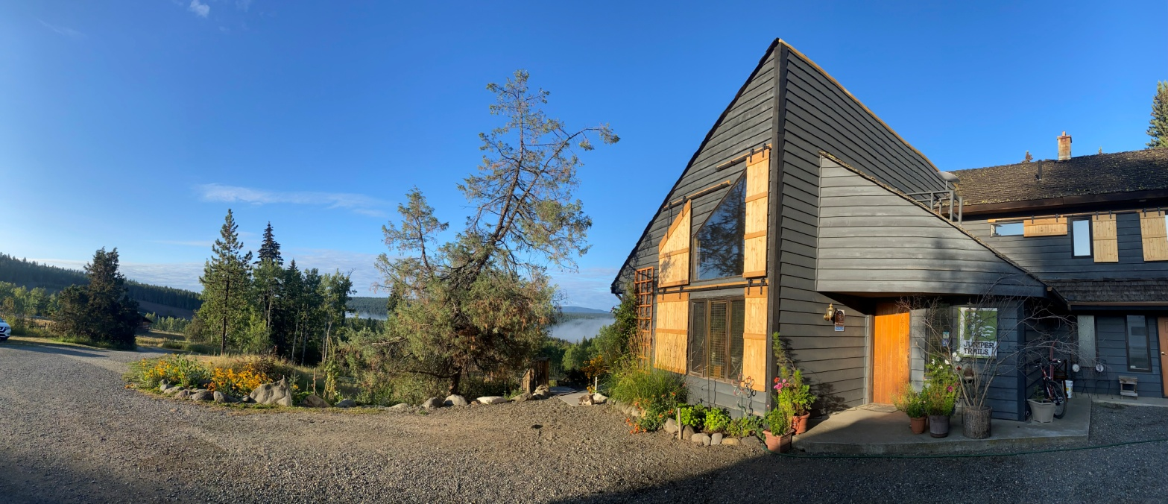

Main Images Gallery
(scroll through, right to left, 5 full width images)

_____________________________________________________________________________________________

